Passive Predicate

✅ What Is a Passive Predicate?
# Source: AI Source: Provided by: [Data Path: Persons Table -> ID Column: 1, Name_En Column: Motasem Essam] -> From: [ChatGPT] on [8/4/2025]
A Passive Predicate is a predicate where the action is done to the subject, rather than the subject doing the action.
It typically includes a form of the verb “to be” followed by a past participle.

🔸 Key Features:
# Source: AI Source: Provided by: [Data Path: Persons Table -> ID Column: 1, Name_En Column: Motasem Essam] -> From: [ChatGPT] on [8/4/2025]
- The subject receives the action.
- Includes a “be” verb (am, is, are, was, were, etc.) + past participle.
- Often includes a prepositional phrase starting with “by” to show the agent (optional).
- Focuses more on the action/result than on the doer.

🔸 Passive vs Active Comparison:
# Source: AI Source: Provided by: [Data Path: Persons Table -> ID Column: 1, Name_En Column: Motasem Essam] -> From: [ChatGPT] on [8/4/2025]
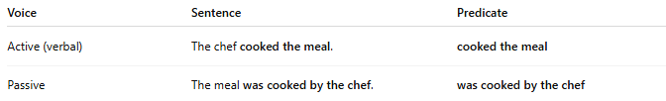
Voice | Sentence | Predicate
Active (verbal) | The chef cooked the meal. | cooked the meal
Passive | The meal was cooked by the chef. | was cooked by the chef

🔸 Examples of Passive Predicates:
# Source: AI Source: Provided by: [Data Path: Persons Table -> ID Column: 1, Name_En Column: Motasem Essam] -> From: [ChatGPT] on [8/4/2025]
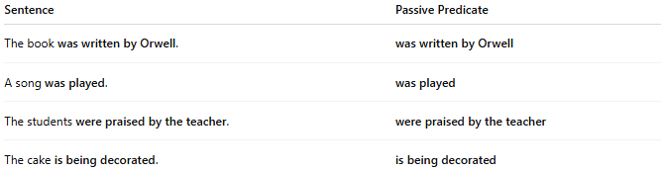
Sentence | Passive Predicate
The book was written by Orwell. | was written by Orwell
A song was played. | was played
The students were praised by the teacher. | were praised by the teacher
The cake is being decorated. | is being decorated

🔸 Passive Predicate Formula:
# Source: AI Source: Provided by: [Data Path: Persons Table -> ID Column: 1, Name_En Column: Motasem Essam] -> From: [ChatGPT] on [8/4/2025]
Subject + [form of “be”] + past participle (+ optional agent)

